|  |  |  |
| --- | --- | --- |
| **Lyng Primary School P.E Knowledge Organiser** | | |
| **Topic: Football** | Year 5 | Autumn 1 |





**"You have to fight to reach your dream. You have to sacrifice and work hard for it” – Lionel Messi**

Enquiry Questions

* How can we improve our control of the football when moving at speed?
* How can we change speed and direction maintaining the control of the ball when dribbling?
* In which positions on the pitch should we attempt a certain pass type?
* What type of shot do we attempt and where on the pitch?
* How should we shape our body when defending a 1 on 1 scenario?
* How can we combine skills we have learnt into game play?

 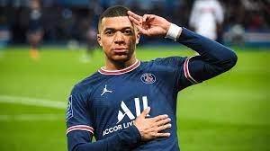



|  |  |
| --- | --- |
| **Key words** | |
| **Spelling** | **Definition** |
| Attacker | Main contribution of an attacker is to focus on creating or taking key opportunities. |
| Passes | To transfer a ball to another team mate. |
| Dribbling | To move whilst in possession of the ball at your feet. |
| Shooting | Aiming for the basket to score for the team. |
| Control | Control could be your first touch when receiving the ball or maintaining control of the ball when dribbling/shooting. |
| Possession | Retain the ball for the team, so your team is in control and have the ball. |
| Communication | To interact using your voice with the team. |
| Tactics | [Methods](https://www.collinsdictionary.com/dictionary/english/method) that you [choose](https://www.collinsdictionary.com/dictionary/english/choose) in order to be successful, i.e. number of passes made, movement, defensive/offensive shape. |
| Defender | Main contribution to the team is to prevent goals and protect the goalkeeper. |

|  |  |  |
| --- | --- | --- |
| **Lyng Primary School P.E Knowledge Organiser** | | |
| **Topic: Football** | Year 5 | Autumn 1 |

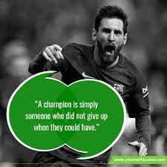 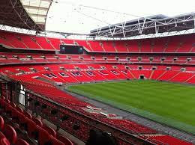

Learning outcomes:

* To develop ball skills and control
* Turn at pace with confidence when dribbling
* To improve our first touch when receiving the ball
* To develop our accuracy when shooting with both feet
* To put defensive qualities into a game scenario
* To understand the rules of the game